**Home task**

**Task 1. Watch the video** [**here**](https://www.youtube.com/watch?v=xay5TeJVSC0&t=5s) **and do the suggested activities. Be ready to hand in the email you get at the end of the video.**

**Task 2. Read the messages below and answer the questions.**

1. Why is the writer thanking the recipient of the message?
2. Are the messages formal or informal? Which words / phrases tell you this?

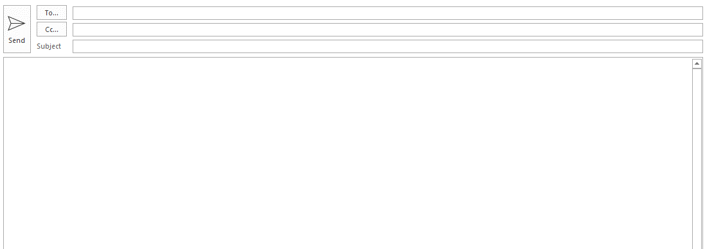

*Hi Vincent,*

*Thanks a lot for yesterday. It was great to hang out with you and I really enjoyed the National Museum, I'll be back next month, so let's get together again*

*Good luck with your exams!*

*Best wishes,*

*Adriana*



*Dear Ms Townsend,*

*Thank you very much for all your help in planning our annual conference. We greatly appreciated your expertise in handling the logistics and the travel arrangements. Everyone at Creavy Associates feels that the conference was a success and this is in no small part, due to your efforts. Please send us your invoice at your earliest convenience.*

*I look forward to hearing from you.*

*Yours sincerely,*

*Mark Appleton*



*Hi Auntie Liz,*

*Thank you ever so much for the gift, which arrived today. It was really kind of you. I'll use the money for a trip to France this summer after graduation!*

*I hope you and Uncle Dave are well,*

*Love,*

*Lou*

**Task 3. Complete the table with phrases from the messages in Task 2.**

|  |  |  |
| --- | --- | --- |
|  | Formal | Informal |
| Starting the message |  | Hi …, |
| Expressing thanks | We greatly appreciated … | Thanks a lot for … |
| Adding more information |  |  |
| Signing off | Yours sincerely, |  |

* **Write the phrases in the box in the correct place in the table in Task 3. Which phrases could be either formal or informal?**

I was delighted to receive ... All the best, I had a great time. Warm regards. See you soon, I am very grateful for your help with ... Thank you very much indeed for... Kind regards,

**Task 4. Read the scenario and write an informal thank you message to the taxi driver.**

You are going home in a taxi late at night. You accidentally leave your bag in the taxi. The bag contains many important personal items. Hours later, you realize what has happened and you cannot remember anything about the taxi. Two days later the bag arrives at your home, with an informal note:

*Hi. You left your bag in my taxi on Saturday. I found you address on two envelopes in the bag.*

*Haluk*

________________________________________________________________________________________________________________________________________________________________________________________________________________________________________________________________________________________________________________________________________________________________________________________________________________________________________________________________________________________________________________________________________________________________________________________________________________________________________________________________________________________________________________________________________________________________________________________________________________________________________________________________________________________________________________________________________________________________________________________________________________________________________________________________________________________________________________________________________________________________________________________________________________________________________________________________________________________________________________________________________________________________________